

**Asia Pacific College`**

Humabon, Makati, 1232 Metro Manila

Hotel Spa Reservation System

Final Project in MCSPROJ

Submitted by:

Giomar T. Andres  
Gene Carlo A. Bongat  
Antonio Salvador S. Garinga  
Edward Joseph R. Mandac  
Gabriel Angelo A. Ngceen  
Caryl Johanan C. Orosco

MI – 153

Table of Contents

**List of Figures, List of Tables, List of Notations** 4

**Abstract**

Introduction

Project Context5  
Purpose and Description5-6  
General Objectives6  
Specific Objectives6  
Scope and Limitations of the Study6-7  
Assumptions of the Study7

**Review of Related Literatures/Systems**

Local Literatures8  
Foreign Literatures8-10  
Common Features10  
Features to be Adapted10

**Technical Background**

Programming Language11

Hardware Requirements11  
 Software Requirements11  
 Human Resource Requirements11

**The Existing System**

Company Background12  
Data Flow Diagram13-14  
Problem Areas14

**The Proposed System**

Process Specification

Data Flow Diagram15-16

Data Specification

Entity Relationship Diagram17  
 Class Diagram18  
 Object Diagram18  
 Data Dictionary19  
 Tables/Files Layout19-20

Screen/Layout Specification21-23

**Methodology, Results and Discussions**

Requirement Documentation

Use Case Diagram24  
 Activity Diagram25-26  
 Sequence Diagram27  
 Interaction Overview Diagram28  
 State Machine Diagram28  
 Composite Structure Diagram29  
 Component Diagram30  
 Package Diagram30  
 Timing Diagram31-32  
 Deployment Diagram33  
 Communication Diagram33

Gap Analysis34

**Bibliography**35

**List of Figures, List of Tables, List of Notations**

* Common Features of RRLs (page 11)
* Data Flow Diagram – Existing and Proposed System (pages 13 – 16)
* Entity-Relationship Diagram (page 17)
* Data Dictionary (page 18)
* Class Diagram (page 20)
* Object Diagram (page 20)
* Use Case Diagram (page 21)
* Fully Dressed Use Case (pages 22 – 23)
* Activity Diagram (pages 24 – 25)
* Sequence Diagram (page 26)
* Gap Analysis (page 26)
* State Machine Diagram (page 30)
* Interaction Overview Diagram (page 30)
* Composite Structure Diagram (page 31)
* Package Diagram (page 32)
* Component Diagram (page 32)
* Timing Diagram (page 33)
* Deployment Diagram (page 34)
* Communication Diagram (page 34)

**INTRODUCTION**

**Project Context**

The client for this project is the Asmara Spa, an affiliate of Taal Vista Hotels, Tagaytay City, Philippines. Currently, the Asmara Spa's booking process, is manually performed. The researcher's task is to create a reservation system for the spa that will automate the process of creating a booking and include an online booking system for potential customers who are looking to avail the different services offered at the Asmara Spa via the internet.

To create a booking in the Asmara Spa, each customer will have to inquire first about what services are available, and what are the available time slot/s on a certain date. A treatment room has its own timetable which determines its availability for a booking. Since the Asmara Spa has multiple treatment rooms, each time slot can be booked as long as there is still an available treatment room. All these data that the Spa was previously handling manually, will be handled by the system in an automated manner as to prevent conflicts in the booking process and provide accurate data in each report.

**Purpose and Description**

The purpose of this project is to mainly provide the client, Asmara Spa of Taal Vista Hotel, a reservation system for their spa that will automate most of the processes in their working environment. Specifically, this project is intended to prevent the errors that result from performing work processes manually. With manual work processes, many errors can occur that will waste time, lose efficiency, and possibly drop customer satisfaction rates which will, in return, reduce the amount of customers of the spa.

The reservation system shows the availability of the spa's services and the available schedules of their treatment rooms by using the data stored within the system. These include previously scheduled bookings to produce accurate information about schedule and service availability. The system also utilizes a web interface for customers who want to make a booking but are not checked-in at the hotel. After the system has processed the booking, the spa assistant assigned to that booking is informed of the details of the booking such as the time and date, the room that will be used, and what service is required.

**General Objective:**

To create and implement an efficient reservation system for the client that automates their work processes. The system's efficiency is measured through the reports generated as it shows the number of bookings made daily.

**Specific Objectives:**

1. To address/prevent the mistakes that occur from doing manual processes. For instance, a wrong date is written on paper or one of the services requested isn't indicated.
2. To make the booking process more accessible via online booking.
3. To reduce the amount of time it takes to make a booking by 30% - 40%.
4. To convert the spa’s work environment into a paperless office.
5. To generate a report that would show spa trends such as the number of bookings made per day, the most requested service,   
   and the peak hours and days.

**Scope and Limitations of the Study**

1. The proposed system will be handling booking requests from walk-in customers and online submissions, whether they may be checked-in at the Taal Vista Hotel or not.
2. The proposed system automatically assigns each customers’ reservation to the spa’s treatment rooms based on the reservation’s time slot chosen.
3. The system will handle the automation of assigning the spa assistant/s for each booking. Informing the spa assistants of the reservation they were assigned to, along with its details such as the date and time, the treatment room to be used, and the service required by the customer is not included in the features of the system. This will have to be done manually.
4. The system will inform each customer of how much their reservation costs and keeps track of the status of their balance. Transactions will have to be made at the spa itself, not at the hotel whether they are checked in or not.
5. For the payment option to be fully functional, the client may have to pay a certain fee to enable it.
6. An SMS feature is supposed to be added to the system to notify users when their booking time is near. Unfortunately, this feature also requires a certain fee for it to be enabled.
7. Monitoring of the spa assistants’ attendance is not included in the features of this system.

**Assumptions of the Study**

1. The pricing for the services offered by the spa is dependent on the service’s duration itself.
2. The spa’s attendants are well-rounded and has their fixed schedule to provide any requested services by the customers.
3. The spa’s receptionist and the marketing department head are the administrators of the system. Both of them will have access to the bookings.

**REVIEW OF RELATED LITERATURE/SYSTEMS**

**Local Systems**

* **ZenSoft Spa & Salon Management System**

ZenSoft is an IT company here in the Philippines which is specialized in developing software for the service industry. ZenSoft is an all-in-one online software specially built for salons and spas. Whether users have a small spa or multi-branch salon, they can use this software. It’s easy to use, cloud-based, intuitive, and robust.

*(*[*http://zensoft.ph/*](http://zensoft.ph/)*)*

*Features:* customer database, employee management, appointment management

**Foreign Systems/Literature**

* **Agilysys**

Spa Management is the nearly effortless software solution that simplifies the appointment process, enhances the guest experience and helps maximize the value of the user’s spa as a revenue center. Spa staff are provided with a detailed list of appointments scheduled, checked in, completed, or on hold. It provides real-time updates for error-free scheduling, tracks guest preferences for up-sell opportunities, creates staff profiles, and delivers increased efficiencies in inventory control. Beautifully simple.

*(*[*http://www.agilysys.com/solutions/by-products/activity-scheduling/spa-management*](http://www.agilysys.com/solutions/by-products/activity-scheduling/spa-management)*)*

*Features:* real-time updates, employee management, appointment management

* **Envision Spa System**

Envision contains three features mainly, Smart Management Tools, Marketing and Online Booking that make it easier and a lot more convenient for both the customer and staff from management to marketing, retailing and reporting. Envision provides all the necessary tools to grow a business. Envision keeps transactions easier, convenient and smooth while still providing enough man power for other task.

*(*[*http://www.envisionsalon.com/*](http://www.envisionsalon.com/)*)*

*Features:* online booking (either through website or through Facebook)

* **MindBody Spa System**

The MindBody Spa system has eight features in it that benefits both business owners and clients. It can be used in a computer and can also be downloaded in Play Store (for Android users) and App Store (for iOS users). The features are marketing, online booking, automation, point of sale, client tools, staff resources, and lastly, reports.

*(*[*https://www.mindbodyonline.com/spa*](https://www.mindbodyonline.com/spa)*)*

*Features:* online booking, customer database, employee management, real-time updates.

* **SalonLite**

SalonLite is a fully optimized cloud solution built with the latest technologies that provides a robust and secure scheduling solution for salons and spas around the world. SalonLite is a quick and easy solution that can be set up and fully functional within a few minutes.

*(*[*https://www.salonlite.com/*](https://www.salonlite.com/)*)*

*Features:* appointment management, online booking.

* **Springer-Miller Systems: SpaSoft**

SpaSoft Spa Management Software is a user-friendly system that facilitates total spa and activity management. As a result, the user’s staff is empowered to provide impeccable service laser-focused on each and every client. SpaSoft interfaces with various systems – including hotel property management systems, credit card and gift card processors, back office systems, membership billing, and other technologies – to create a seamless flow of guest-centric information.

*(*[*http://www.springermiller.com/solutions/hotel-resort-spa/*](http://www.springermiller.com/solutions/hotel-resort-spa/)*)*

*Features:* integration into hotel systems, online booking, customer database

**Features to be Adapted from Related Systems**

|  |  |  |  |
| --- | --- | --- | --- |
|  | **Online Booking** | **Customer Database** | **Generates Reports and Analytics** |
| **Zensoft Spa & Salon Management System** |  | **✓** | **✓** |
| **Agilysys** |  |  | **✓** |
| **Envision Spa System** | **✓** |  | **✓** |
| **Mindbody Spa System** | **✓** | **✓** | **✓** |
| **SalonLite** | **✓** | **✓** | **✓** |
| **Springer-Miller Systems: SpaSoft** | **✓** | **✓** | **✓** |

**Features of the Proposed System**

* **Customer Database** 
  + Storing of guest profiles, identifying new and returning customers.
* **Online Booking**
  + The system is constantly running 24/7 for it to be able to still accept reservations during off-hours. In case of power interruptions, the back-up plan is for the spa to revert to the manual process.
* **Reports**
  + Daily reports which shows the trends on that certain day.

**TECHNICAL BACKGROUND**

**Programming Language**

The program is built purely in the platform Wordpress, a free and open-source content management system (CMS), based on PHP and MySQL.

* + - **PHP -**is a server-side scripting language designed primarily for web development but also used as a general-purpose programming language.

**Resource Requirements**

**Hardware Requirements**

* + - **CPU –** Intel Pentium Core 2 Duo
    - **Disk Space** – 1 GB
    - **RAM –** 1 GB

**Software Requirements**

* + - **Web Service** – Nginx Server or Apache Server
    - **Database Server -** MySQL
    - **Browser –** Internet Explorer, Microsoft Edge, Mozilla Firefox, Google Chrome or Safari
    - **Operating System –** Windows, Linux or MAC OSX

**Human Resource Requirements**

* **Receptionist** - will be the one to use the system in the front desk.

**THE EXISTING SYSTEM**

**Company Background**

In early 1935, then Commonwealth President Manuel L. Quezon expressed interest in developing Tagaytay as a tourist destination. In 1939, the Zamoras of Manila Hotel built Taal Vista Lodge along “Ilong Kastila”—a stretch of flatland perched atop an incline which people said resembled a nose.

During the Second World War from 1942 to 1944, Taal Vista Lodge was converted to an officers’ quarters for the Japanese. In February 1945, the 11th Airborne Division of the US Army assist the liberation of Manila. Between 1956 and 1964 Tagaytay began to bepromoted as a major tourist destination in the Philippines with Taal Vista Lodge. One of the many regular visitors of the hotel was a young man who often chose one spot on the grounds from which to gaze out and dream. He is Henry Sy of SM Investments Corporation—the company that would later acquire Taal Vista Hotel.

In 2002, Taal Vista Hotel was reconstructed in the style of the original lodge. Facilities and amenities were added for business and leisure activities. In 2004, after its renovation, the Hotel welcomed back its guests. Today, Taal Vista Hotel remains a landmark deeply entrenched in the history and heritage of Tagaytay City.

**Data Flow Diagram**

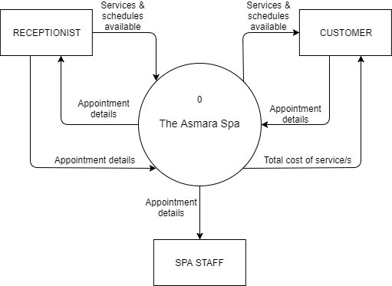**Context Diagram**

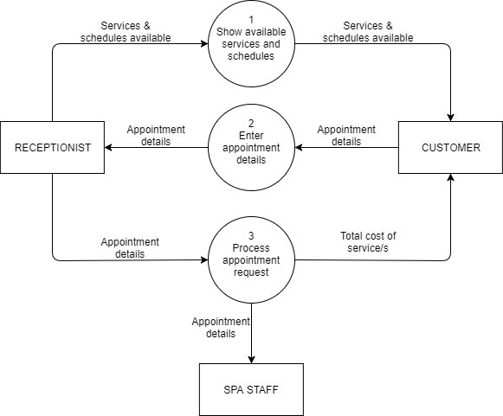**Level 0**

**Level 1 DFD for Process #3**

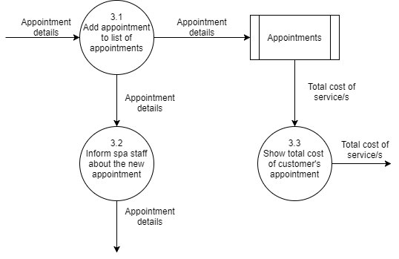

**Problem Areas**

The problem of the existing system includes manual work processes, and overlapping of reservations. Manual work may take more time to process the services that the customer wants which leads to inefficiency. Reservation requests from the existing system may overlap and cause errors.

**THE PROPOSED SYSTEM**

**Process Specification**

**Data Flow Diagram**

**Context Diagram (Online booking)**

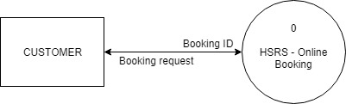

**Level 1 DFD (Online booking)**

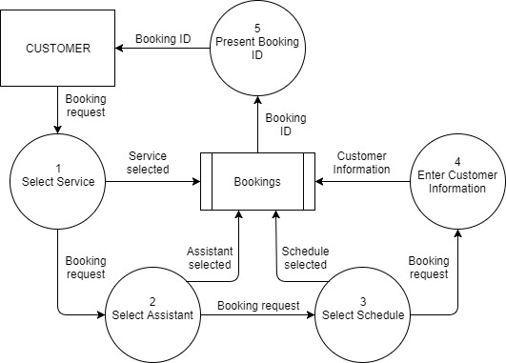

**Context Diagram (Onsite system)**

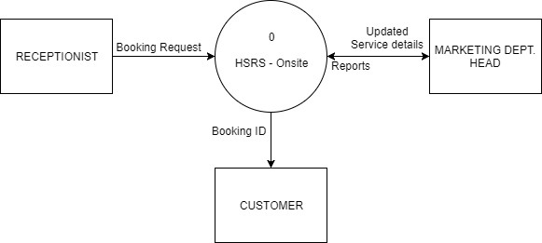

**Level 1 DFD (Onsite system)**

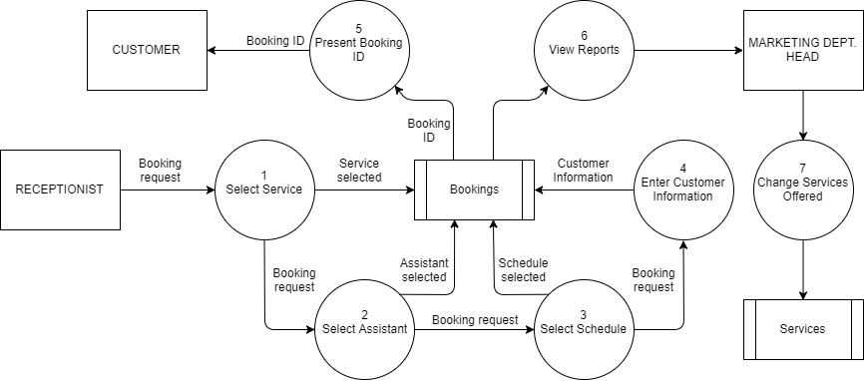

**Data Specification**

**Entity-Relationship Diagram**

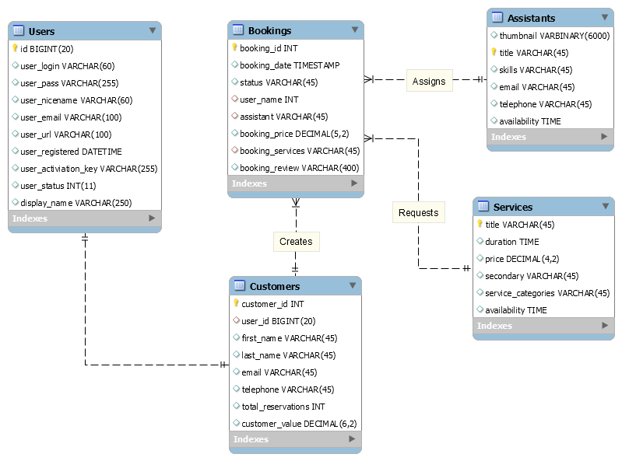

**Class Diagram**

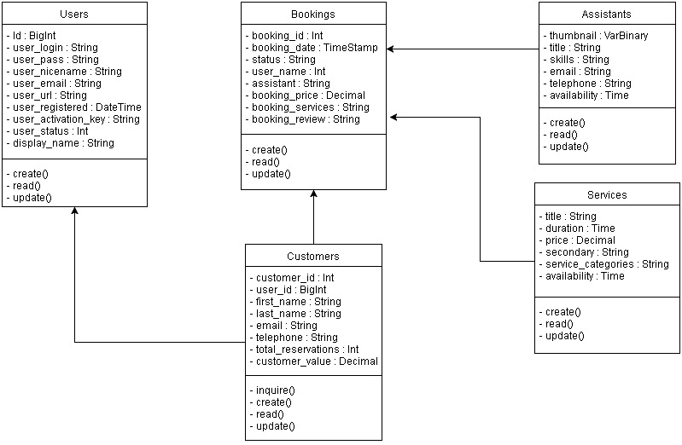

**Object Diagram**

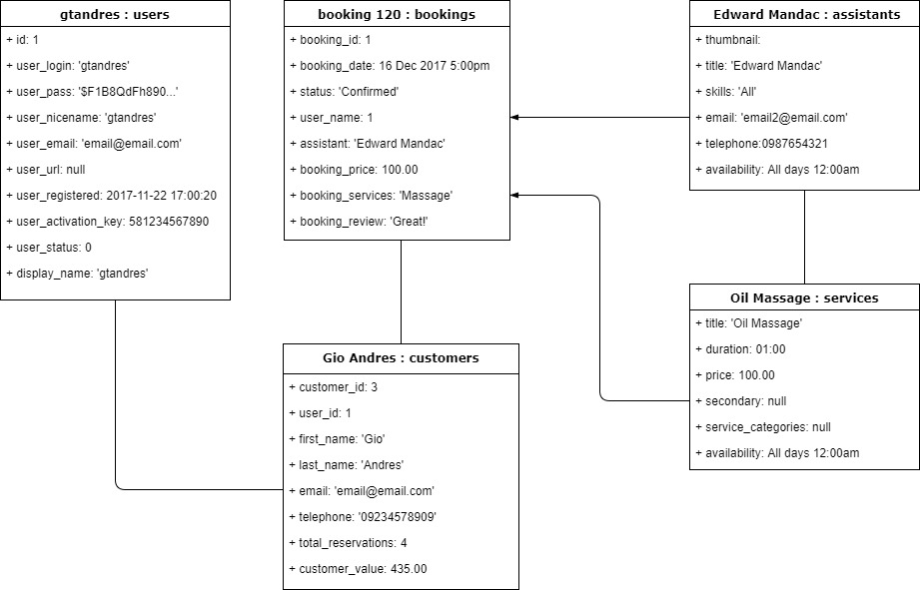

**Data Dictionary**

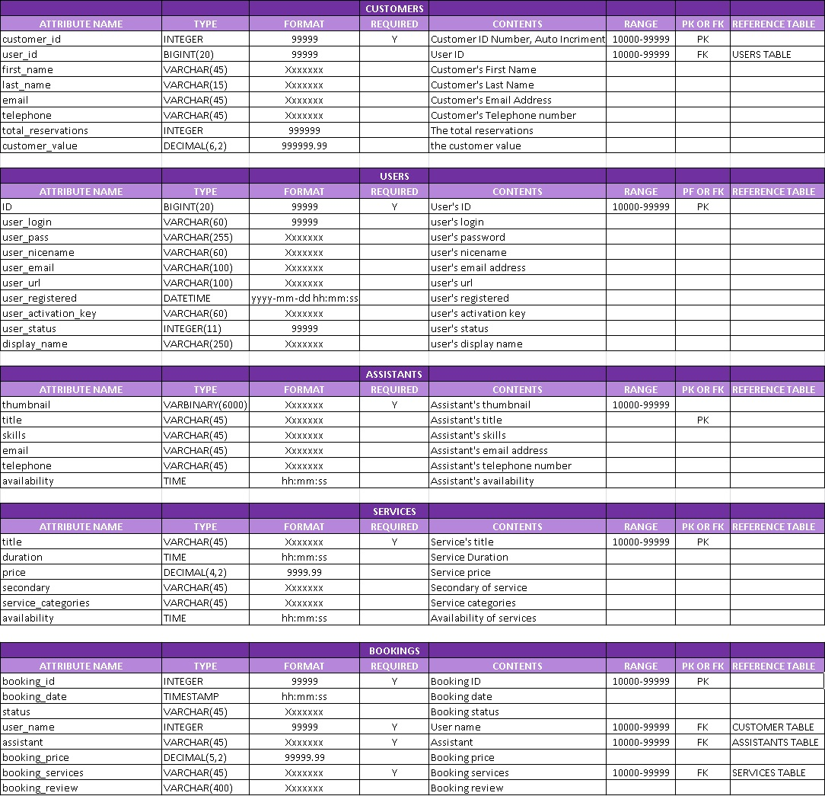

**Tables/Files Layout**

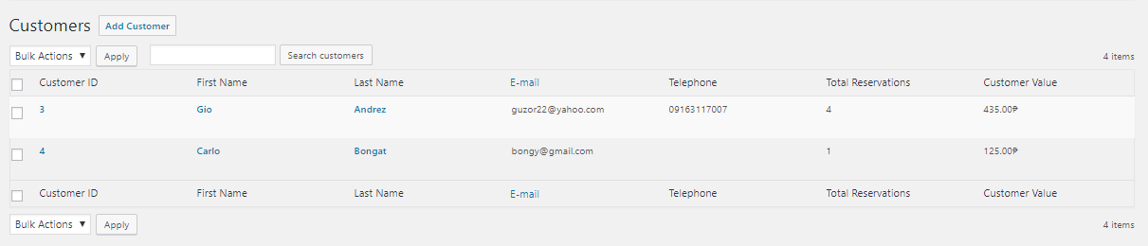

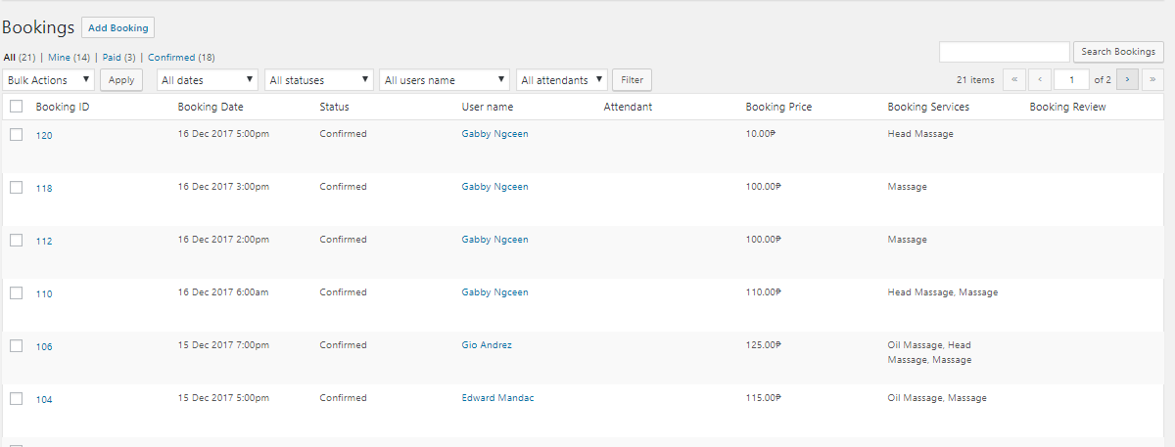

**Users Table**

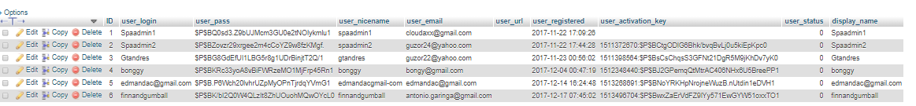

**Services Table**

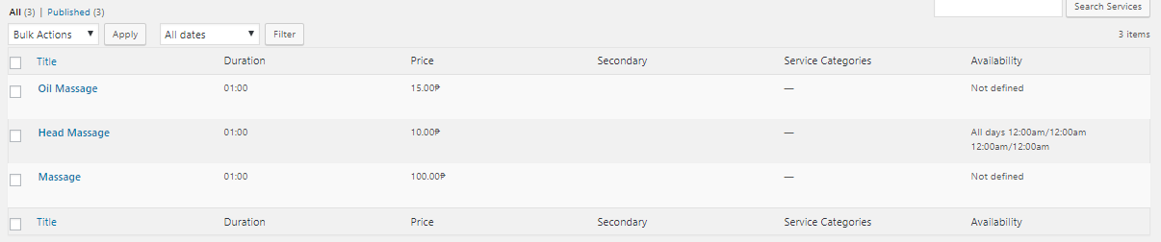

**Assistants Table**

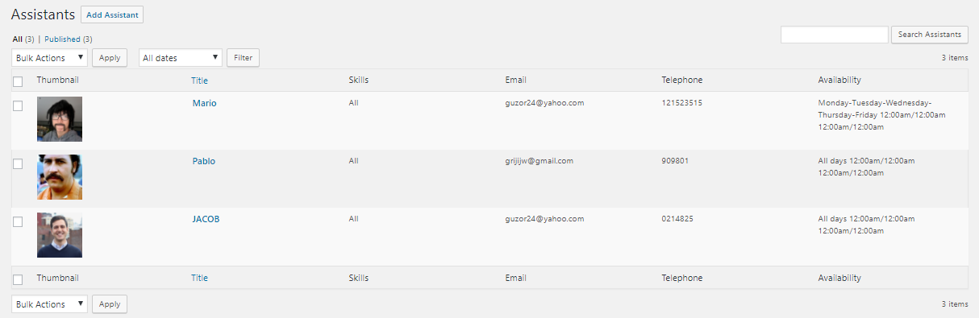

**Screen Layout/Specifications**

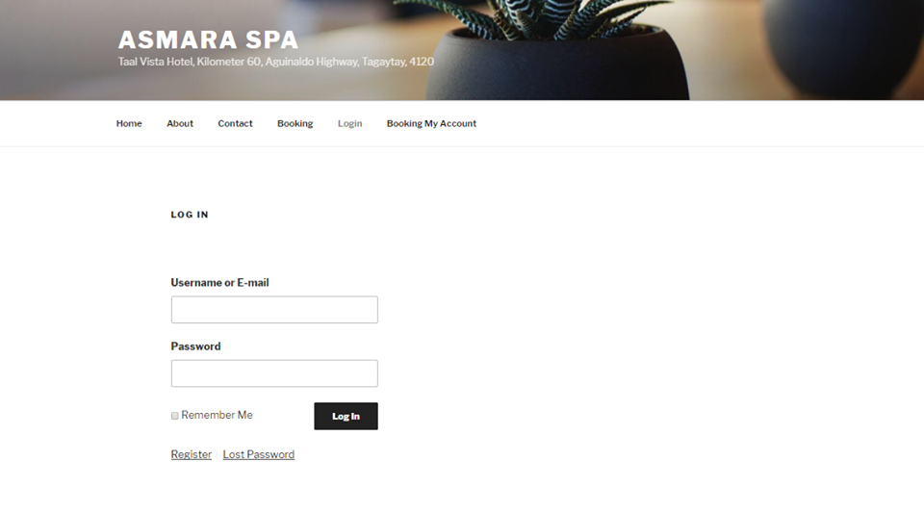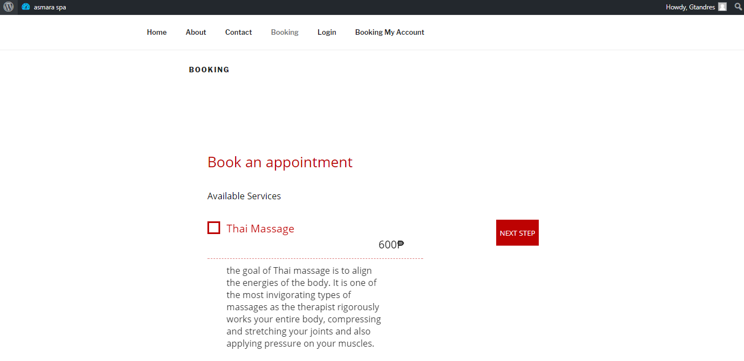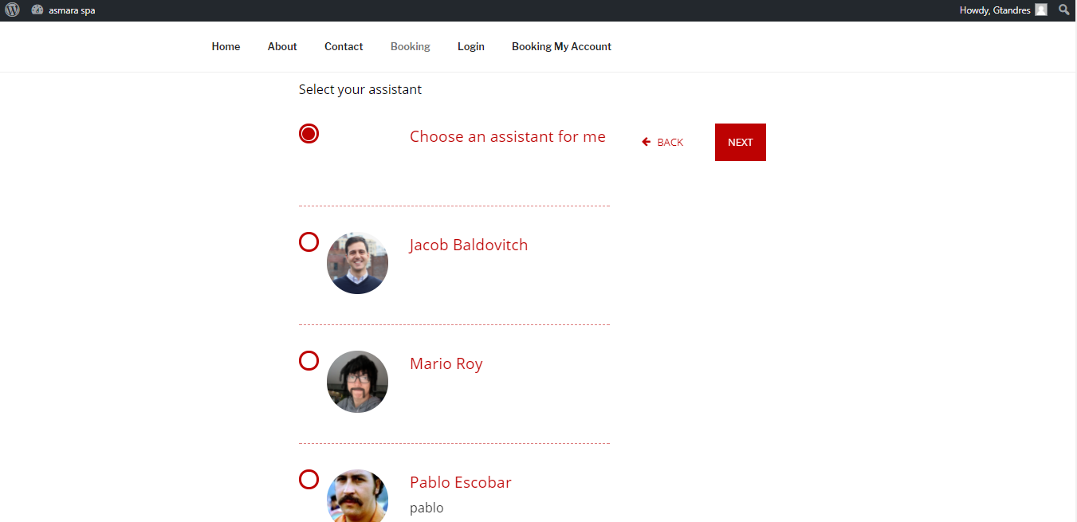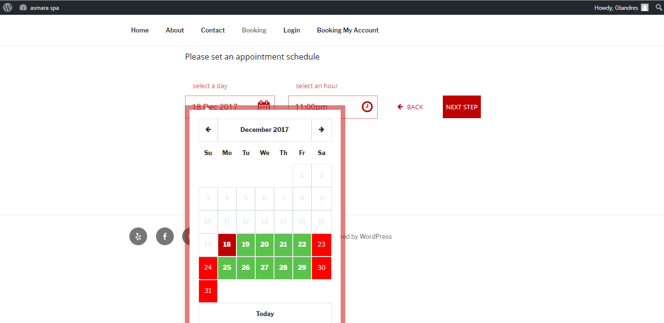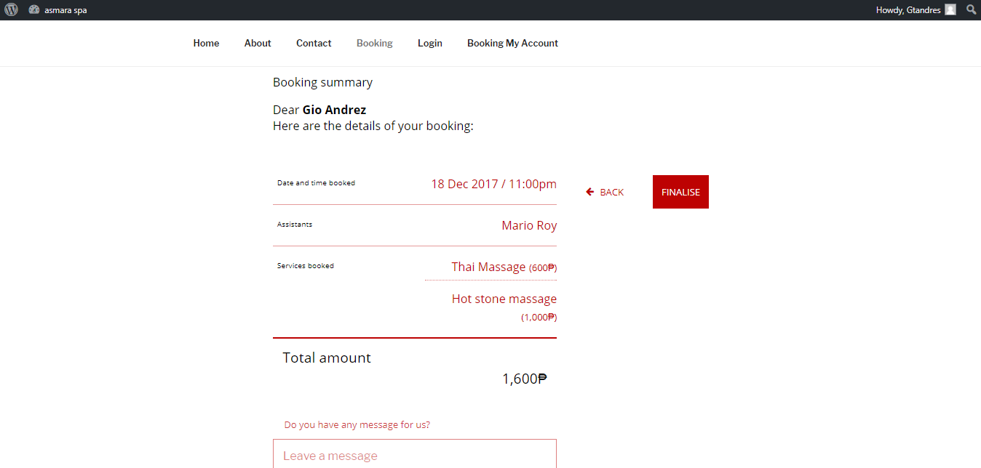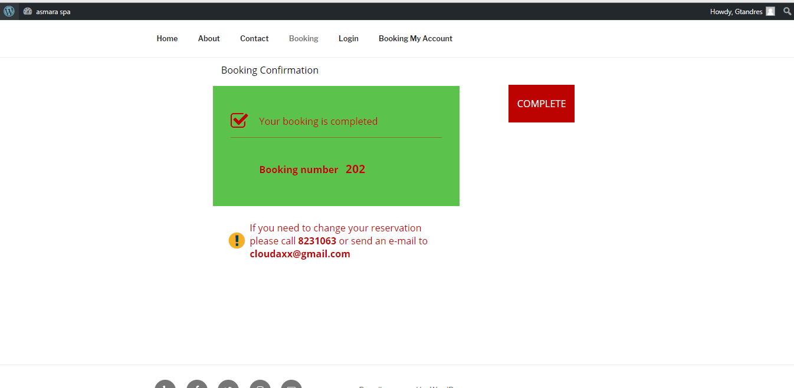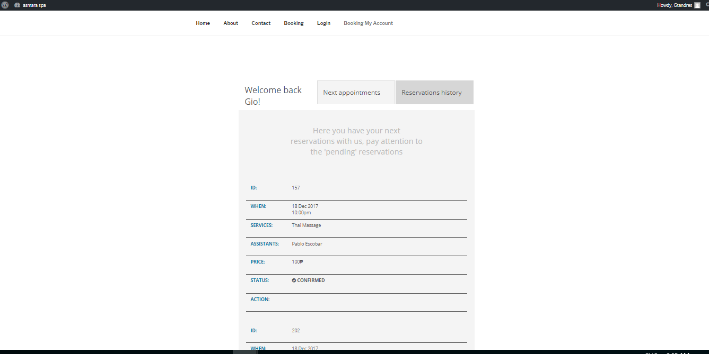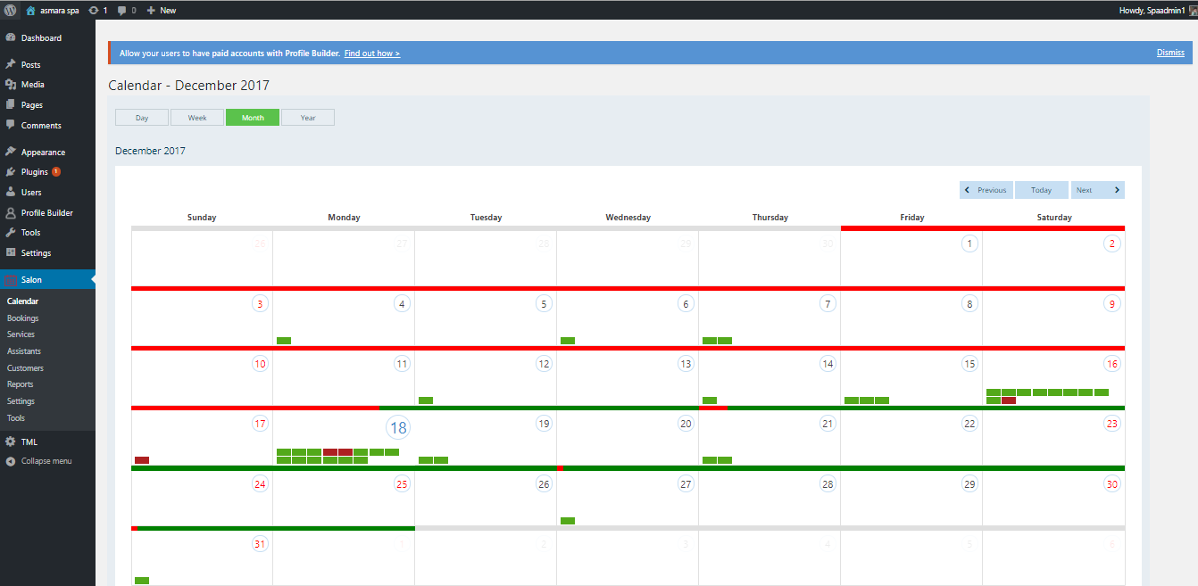

**METHODOLOGY, RESULTS AND DISCUSSION**

**Requirement Documentation**

**Use Case Diagram**

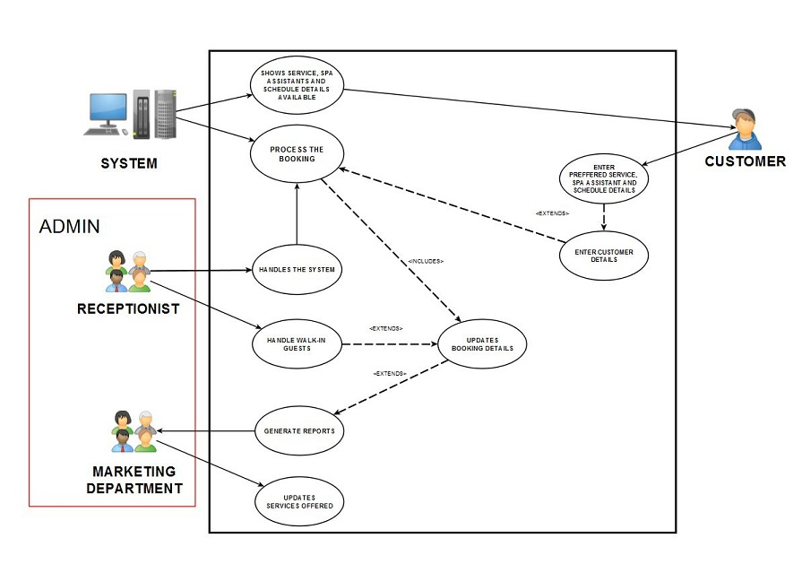

**Activity Diagram (Online booking)**

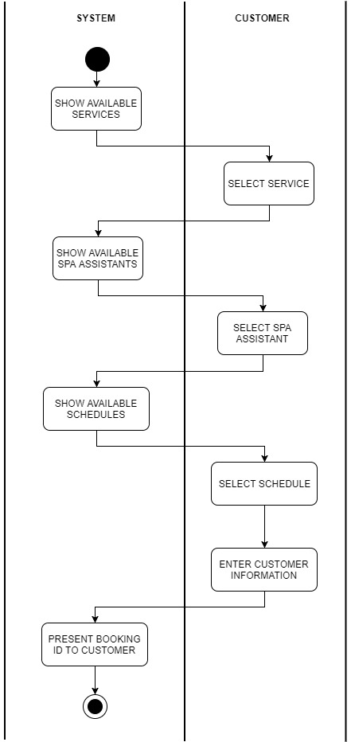

**Activity Diagram (Onsite System)**

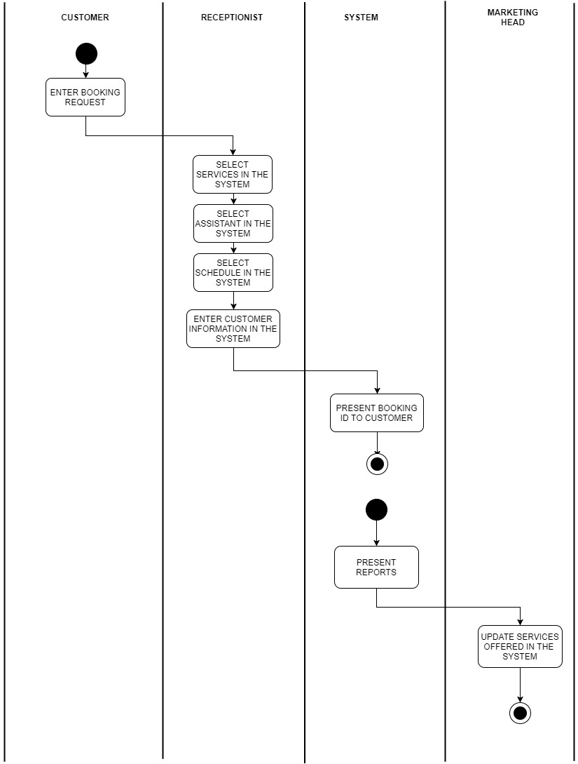

**Sequence Diagram (Online booking)**

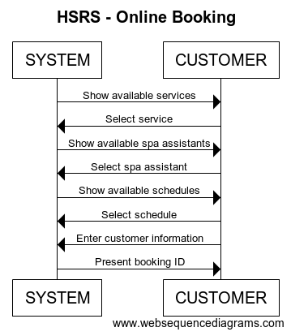

**Sequence Diagram (Onsite System)**

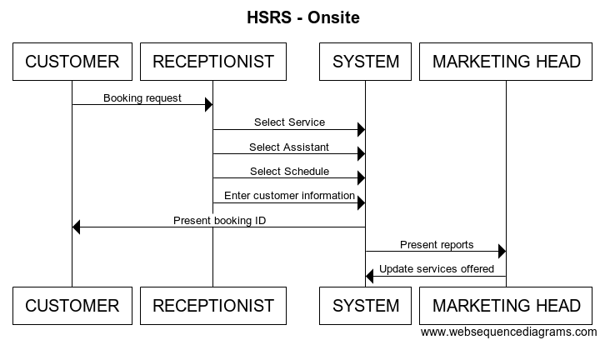

**Interaction Overview Diagram**

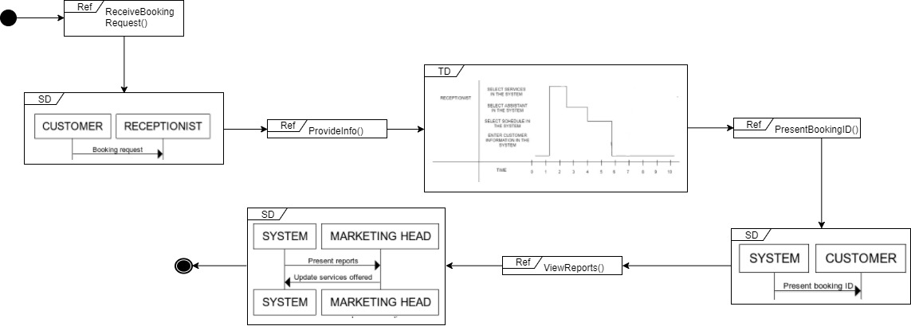

**State Machine Diagram**

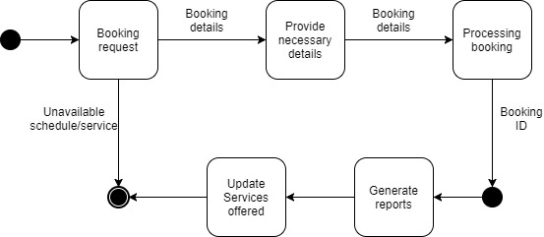

**Composite Structure Diagram**

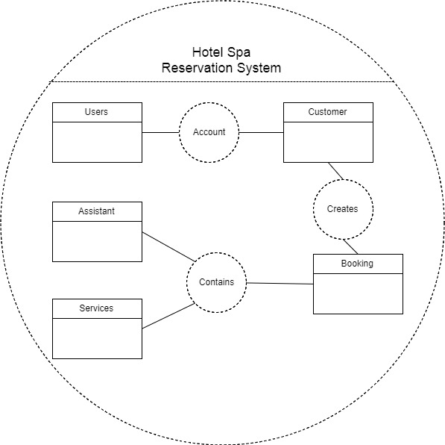

**Component Diagram**

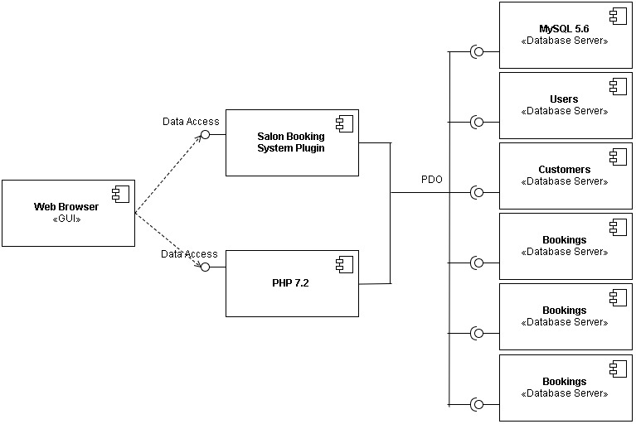

**Package Diagram**

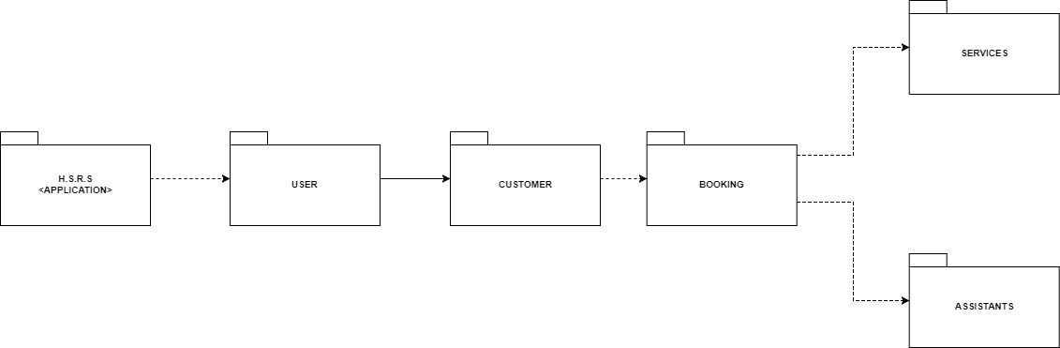

**Timing Diagram (Online booking)**

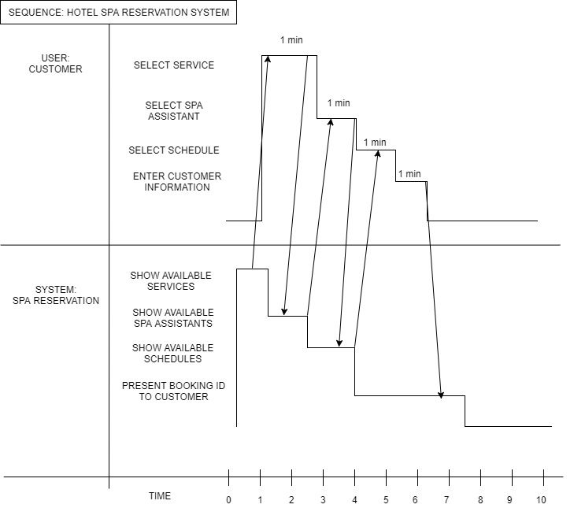

**Timing Diagram (Onsite System)**

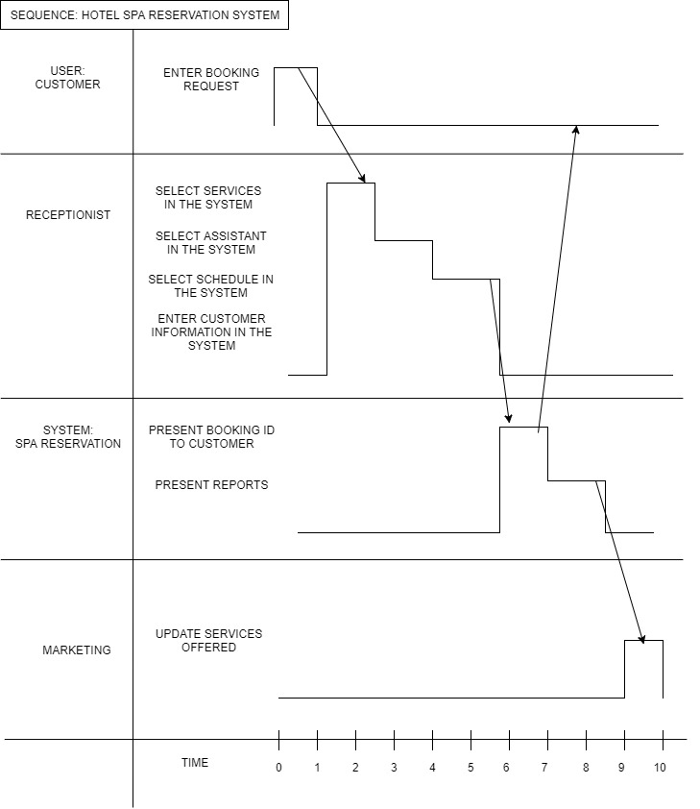

**Deployment Diagram**

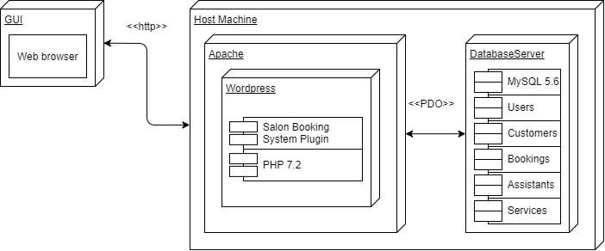

**Communication Diagram**

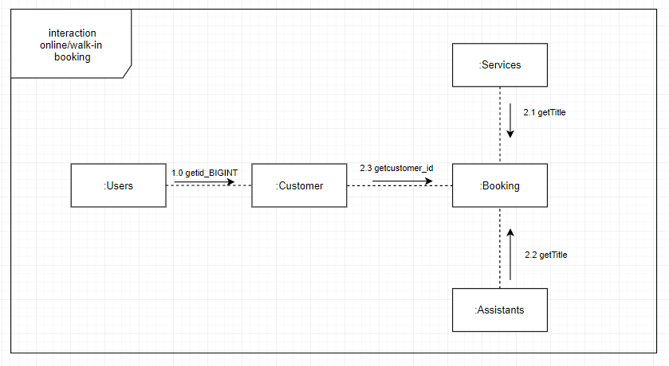

**Gap Analysis**

|  |  |  |
| --- | --- | --- |
| User Requirements | Current Process | Proposed Changes |
| The system addresses/prevents the mistakes that occur from doing manual work processes. | All processes in the Asmara Spa is manual. In line with this, a lot of errors could occur. (e.g. lost appointments, wrong dates written on appointments) | The system will automate the process of making a booking and include an online reservation system for potential customers who are looking to make a booking to the Asmara Spa via the internet. |
| To make the booking process more accessible | The booking process is a bit inconvenient because one way to make an appointment is through a third party website and none on their hotel website. | A web based system for customers who’d want to book a reservation but isn’t a guest checked-in at the hotel that will serve as an alternative. |
| To reduce the amount of time and resources needed in the booking process | In a manual work process, with errors occurring , a lot of time could be wasted fixing mistakes and it would require several people to do a certain task | The system aims to automate work processes so that less time and people are needed to complete a task. |
| To convert the spa’s work environment into a paperless office | Since every booking is manually done, it is assumed that they are currently logged into a log book or slips are compiled into a folder. | With the use of the system, the use of paper will gradually lessen. |
| To generate a report that would show spa trends | To see what trends, the spa has to review their list of reservations/bookings and manually tally the data enlisted in it. | The system will generate a report based from the data collected in the system’s database server, which will show how many reservations they had for the day, what is the most popular service, and what are the peak hours and days. |

# Bibliography

(n.d.). Retrieved from Taal Vista Hotel: http://www.taalvistahotel.com/overview

Ambler, S.W. (n.d.). *Introduction to the Diagrams of UML 2.X.* Retreived from Agile Modeling: http://agilemodeling.com/essays/umlDiagrams.htm

Bodeker, M. C. (2008). *Understanding the Global Spa Industry: Spa Management.* Burlington: Elsevier Linacre House.

Corporation, A. (n.d.). *Fully-Dressed Use Case Sample.* Retrieved from https://image.slidesharecdn.com/slides-aras-plm-software-implementation-methodology-121023101444-phpapp02/95/aras-plm-software-implementation-methodology-38-638.jpg?cb=1350987433

*PHP.* (n.d.). Retrieved from Wikipedia: https://en.wikipedia.org/wiki/PHP

*SQL.* (n.d.). Retrieved from Wikipedia: https://en.wikipedia.org/wiki/SQL